

Low Level Design

**Bank Marketing Analytics**

|  |  |
| --- | --- |
| **Written By** | **Aditya Gautam** |
| **Document Version** | **3.0** |
| **Last Revised Date** | **14-April-2023** |



**DOCUMENT CONTROL**

## Change Record:

|  |  |  |  |
| --- | --- | --- | --- |
| **VERSION** | **DATE** | **AUTHOR** | **COMMENTS** |
| 1.0 | 30-Mar-2023 | Aditya Gautam | Introduction and architecture defined |
| 2.0 | 30-Mar-2023 | Aditya Gautam | Architecture & Architecture description appended and updated. |
| 3.0 | 14-April- 2023 | Aditya  Gautam | Deployement and Conclusion appended and updated |
|  |  |  |  |

**Reviews:**

|  |  |  |  |
| --- | --- | --- | --- |
| **VERSION** | **DATE** | **REVIEWER** | **COMMENTS** |
|  |  |  |  |

**Approval Status:**

|  |  |  |  |  |  |
| --- | --- | --- | --- | --- | --- |
| **VERSION** | **REVIEW**  **DATE** | **REVIEWED BY** |  | **APPROVED BY** | **COMMENTS** |
|  |  |  |  |  |  |



**Contents**

1. Introduction 1
   1. What is Architecture design document?
   2. Scope

1. Architecture
   1. Architecture of the Bank Marketing Analytics 2-8
   2. Life Cycle of Machine Learning Project
   3. Detailed Architecture of Bank Marketing Analytics
   4. Jupyter Notebook Architecture
   5. Power BI Architecture
2. Architecture Description 9-16
   1. Data Description
   2. Importing the Libraries in Jupyter Notebook
   3. Importing the Dataset in Jupyter Notebook
   4. Exploratory Data Analysis
   5. Feature Engineering

3.6 Split into Train and Test Data

3.7 Label Encoder and Get Dummies

3.8 Hyper parameter Tuning

3.9 Model Training and Model Prediction

3.10 Confusion Matrix and Mean Squared Error

3.11 Submission of the Predicted Values

4. Deployment 17-19

4.1 Load the Dataset in Power BI

4.2 Create the interactive dashboard

4.3 Publish to Power Bi account

4.4 Publish to Web

4.5 Share the Public Link to Client

**5. Conclusion**

**5.1 Insight of the Bank Marketing Analytics 20**

1. **Introduction**

* 1. **What is Low Level document?**

The Low level document is to give the internal logic design of the code for the Bank Marketing Analytics dashboard. LDD describes the class diagrams with the methods and relations between classes and programs specification. It describes the modules so that the person can directly code the program from the document.

It gives the person a complete overview about the whole project, which helps to understand the step by step process how to proceed the project and complete it.

* 1. **Scope**

Low-level design (LLD) is a component-level design process that follows a step-by-step refinement process. The process can be used for designing data structures, required software architecture, source code and ultimately, performance algorithms. Overall, the data organization may be defined during requirement analysis and then refined during data design work.

2. **Architecture**

2.1 **Architecture of the Bank Marketing Analytics**

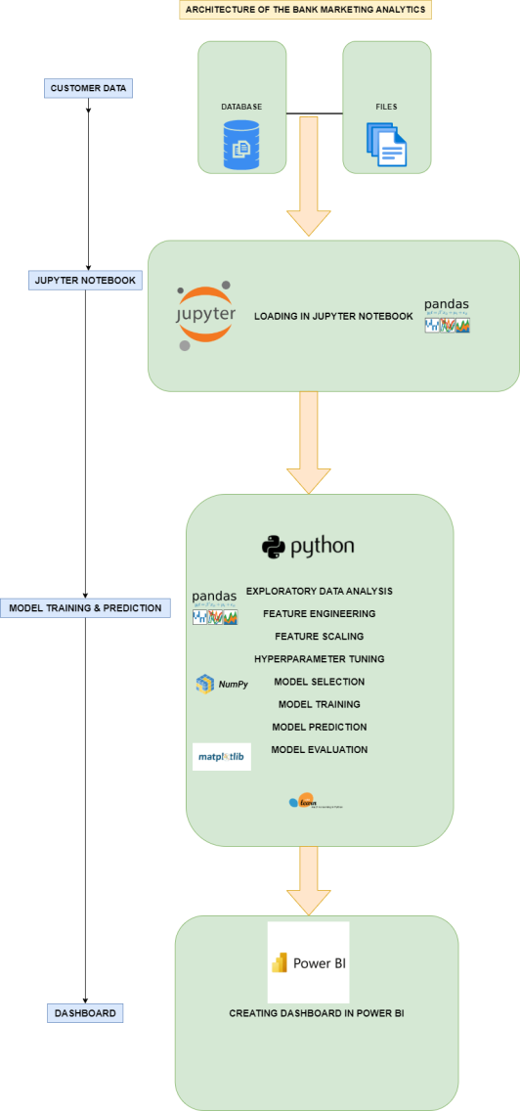

The detailed architecture of the Bank Marketing Analytics has been discussed in the above architecture diagram which gives a overview of the step by step process of the project which gives an idea about flow of the data from original sources to database, then exporting the data from database to importing the data into jupyter notebook by using pandas library for data cleaning process, then for visualize the data, visualization library such Matplotlib and seaborn is used for the purpose and pandas library is used for Feature engineering. Then scikit learn library is used for feature selection , model training, hyperparameter tuning and model evaluation of the data. And finally, deploying the trained data into Power Bi for creating an interactive dashboard.

2.2 **Life Cycle of Machine Learning Project**

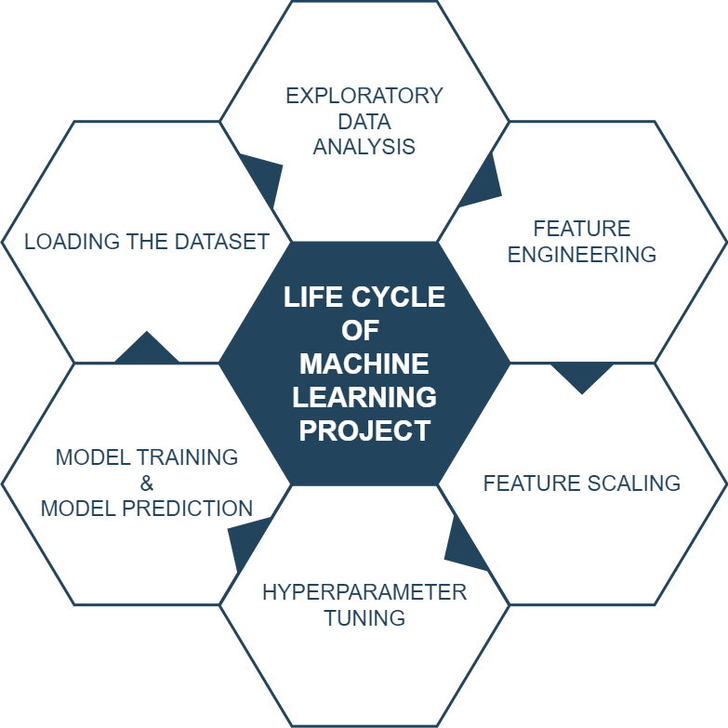

2.3 **Detailed Architecture of Bank Marketing Analytics**

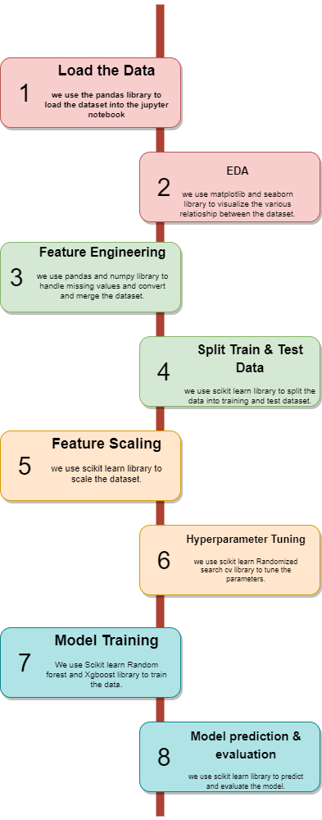

**2.4 Jupyter Notebook Architecture**

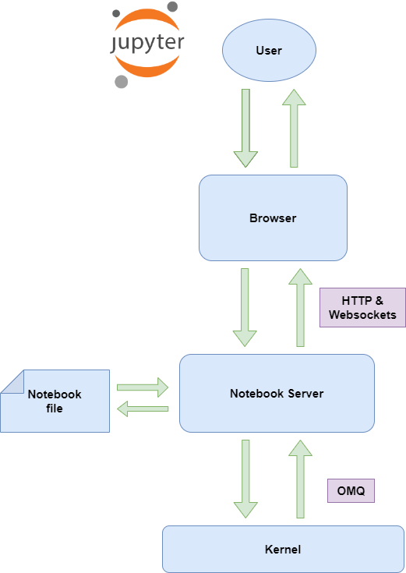

Jupyter Notebook and its flexible interface extends the notebook beyond code to visualization, Multimedia, collaboration, and more. In addition to running your code and output, together with markdown notes, in an editable document called. When you save it, this is sent your browser to the notebook server, which saves it on disk as JSON file with a .ipynb extension.

The notebook server is a communication hub. The browser, notebook file on disk, and kernel cannot talk to each other directly. They communicate through the notebook server. The notebook server, not the kernel, is responsible for saving and loading notebooks, so you can edit notebooks even if you don’t have the kernel for that language-- you just won’t be able to run code. The kernel doesn’t know anything about the notebook document, it just gets sent cells of code to execute when the user runs them.

2.5 **Power BI Architecture**

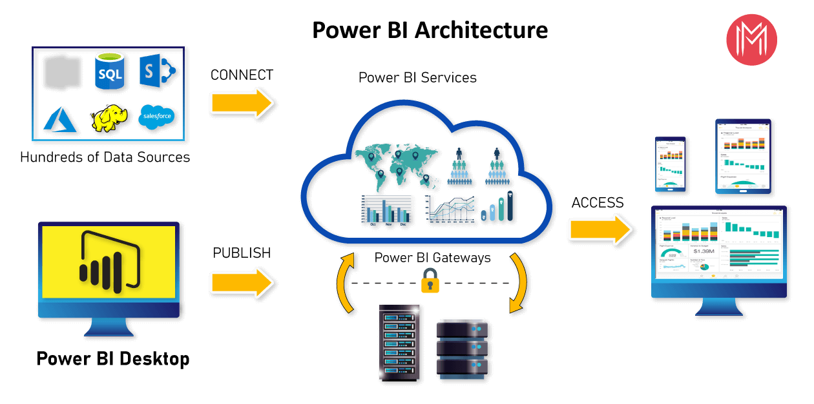

**Power BI**

Power BI is a business analytics solution that lets you visualize your data and share insights across your organization, or embed them in your app or website. Connect to hundreds of data sources and bring your data to life with live dashboards and reports.

2.5.1. **Data sources**

The most important component of Power BI is its vast range of data sources.

 You can import data from files in your system, cloud-based online data sources or connect directly to live connections. The some of the important data sources are given below:

* 1. Excel
  2. Text/CSV
  3. JSON
  4. XML
  5. MySQL Database
  6. PostgreSQL Database
  7. Snowflake

#### 2.5.2. Power BI Desktop

Power BI Desktop is a client-side tool known as a companion development and authoring tool.

Power BI Desktop has tools and functionalities to connect the data sources, transform the data, data modeling and creating interactive dashboard.

Using Power BI Desktop features, one can dodatacleansing, create business metrics and data models, define the relationship between data, define hierarchies, create visuals and publish reports.

1. Connecting to your data, Access data from hundreds of supported on-premises and cloud-based sources, such as Dynamics 365, Salesforce, Azure SQL DB, Excel, and SharePoint. Ensure it’s always up to date with automated, incremental refreshes. Power BI Desktop enables you to develop deep, actionable insights for a broad range of scenarios.
2. Preparing and modeling your data with ease, Data prep can take most of your time, but it doesn’t have to with data modeling tools. Reclaim hours in your day using the self-service Power Query experience familiar to millions of Excel users. Ingest, transform, integrate and enrich data in Power BI.
3. Provide advanced analytics with the familiarity of Excel, Dig deeper into data and find patterns you may have otherwise missed that lead to actionable insights. Use features like quick measures, grouping, forecasting, and clustering. Give advanced users full control over their model using powerful DAX formula language. If you’re familiar with Excel, you’ll feel at home in Power BI.
4. Create stunning reports with interactive data visualizations. Tell your data story using a drag-and-drop canvas and hundreds of modern data visuals from Microsoft and partners—or create your own, using the Power BI open source custom visuals framework. Design your report with theming, formatting, and layout tools.

#### 2.5.3. Power BI Service

Power BI Service is a web-based platform from where you can share reports made on Power BI Desktop, collaborate with other users, and create dashboards.

It is available in three versions:

* Free version
* Pro version
* Premium version

#### 2.5.4. Power BI Report Server

The Power BI Report Server is similar to the Power BI Service. The only difference between these two is that Power BI Report Server is an on-premise platform. It is used by organizations who do not want to publish their reports on the cloud and are concerned about the security of their data.

Power BI Report Server enables you to create dashboards and share your reports with other users following proper security protocols. To use this service, you need to have a Power BI Premium license.

#### 2.5.5. Power BI Gateway

This component is used to connect and access on-premise data in secured networks. Power BI Gateways are generally used in organizations where data is kept in security and watch. Gateways help to extract out such data through secure channels to Power BI platforms for analysis and reporting.

#### 2.5.6. Power BI Mobile

Power BI Mobile is a native Power BI application that runs on iOS, Android, and Windows mobile devices. For viewing reports and dashboards, these applications are used.

#### 2.5.7. Power BI Embedded

Power BI Embedded offers APIs which are used to embed visuals into custom applications.

3. **Architecture Description**

3.1. **Data Description**

This dataset contains 4 files.:

1) bank-additional-full.csv with all examples (41188) and 20 inputs, ordered by date (from May 2008 to November 2010)

2) bank-additional.csv with 10% of the examples (4119), randomly selected from 1), and 20 inputs.

3) bank-full.csv with all examples and 17 inputs, ordered by date (older version of this dataset with fewer inputs).

4) bank.csv with 10% of the examples and 17 inputs, randomly selected from 3 (older version of this dataset with fewer inputs).

Input variables:

Bank client data:

1 - age (numeric)

2 - job : type of job (categorical: 'admin.','blue-collar','entrepreneur','housemaid','management','retired','self-employed','services','student','technician','unemployed','unknown')

3 - marital : marital status (categorical: 'divorced','married','single','unknown'; note: 'divorced' means divorced or widowed)

4 - education (categorical: 'basic.4y','basic.6y','basic.9y','high.school','illiterate','professional.course','university.degree','unknown')

5 - default: has credit in default? (categorical: 'no','yes','unknown')

6 - housing: has housing loan? (categorical: 'no','yes','unknown')

7 - loan: has personal loan? (categorical: 'no','yes','unknown')

# related with the last contact of the current campaign:

8 - contact: contact communication type (categorical: 'cellular','telephone')

9 - month: last contact month of year (categorical: 'jan', 'feb', 'mar', ..., 'nov', 'dec')

10 - day_of_week: last contact day of the week (categorical: 'mon','tue','wed','thu','fri')

11 - duration: last contact duration, in seconds (numeric). Important note: this attribute highly affects the output target (e.g., if duration=0 then y='no'). Yet, the duration is not known before a call is performed. Also, after the end of the call y is obviously known. Thus, this input should only be included for benchmark purposes and should be discarded if the intention is to have a realistic predictive model.

# other attributes:

12 - campaign: number of contacts performed during this campaign and for this client (numeric, includes last contact)

13 - pdays: number of days that passed by after the client was last contacted from a previous campaign (numeric; 999 means client was not previously contacted)

14 - previous: number of contacts performed before this campaign and for this client (numeric)

15 - poutcome: outcome of the previous marketing campaign (categorical: 'failure','nonexistent','success')

# social and economic context attributes

16 - emp.var.rate: employment variation rate - quarterly indicator (numeric)

17 - cons.price.idx: consumer price index - monthly indicator (numeric)

18 - cons.conf.idx: consumer confidence index - monthly indicator (numeric)

19 - euribor3m: euribor 3 month rate - daily indicator (numeric)

20 - nr.employed: number of employees - quarterly indicator (numeric)

Output variable (desired target):

21 - y - has the client subscribed a term deposit? (binary: 'yes','no')

3.2 **Importing the Libraries in Jupyter Notebook**

Importing the Libraries are the most important and intial feature in jupyter notebook, where the libraries such as pandas, numpy, matplotlib , seaborn, Sklearn etc is imported in the notebook.

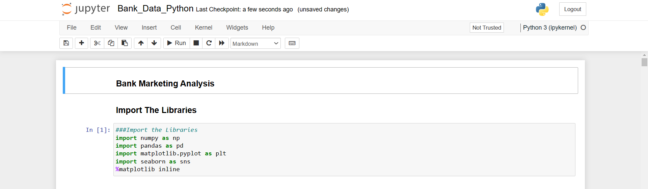

3.3 **Importing the Dataset in Jupyter Notebook**

Importing the dataset is the vital step in the jupyter notebook, where the dataset is imported using the pandas library read_csv is used to import the dataset.

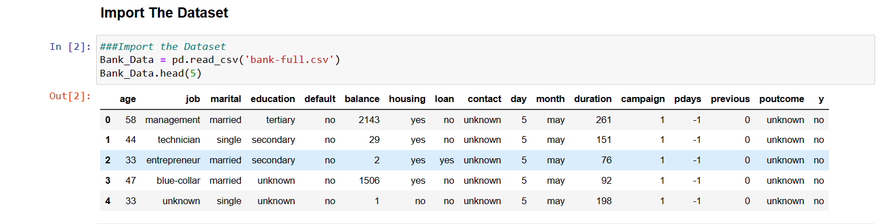

3.4 **Exploratory Data Analysis**

After the dataset is imported, Exploratory Data Analysis is done on the dataset, where various plotting of the data is done using matplotlib and seaborn library. Which helps to understand about correlation of the data, missing values present in the data and outliers present on the data.

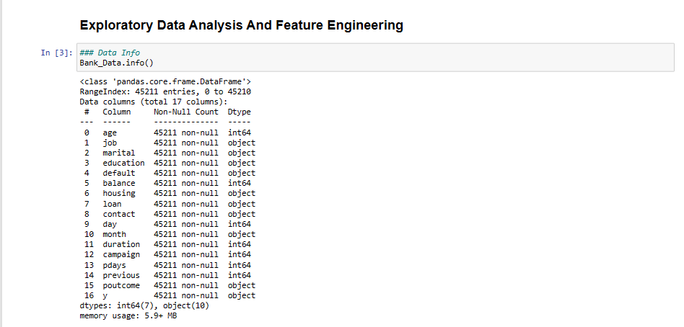

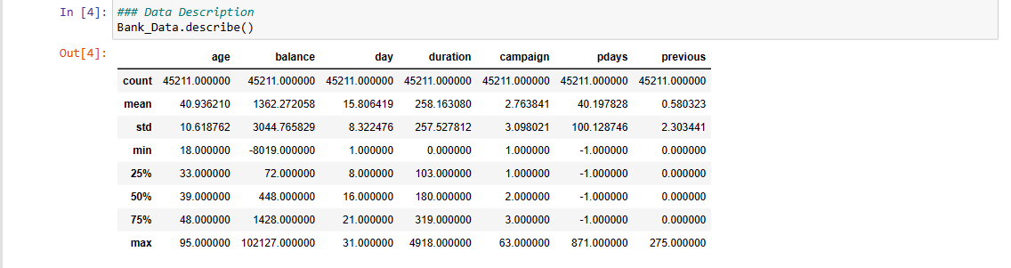

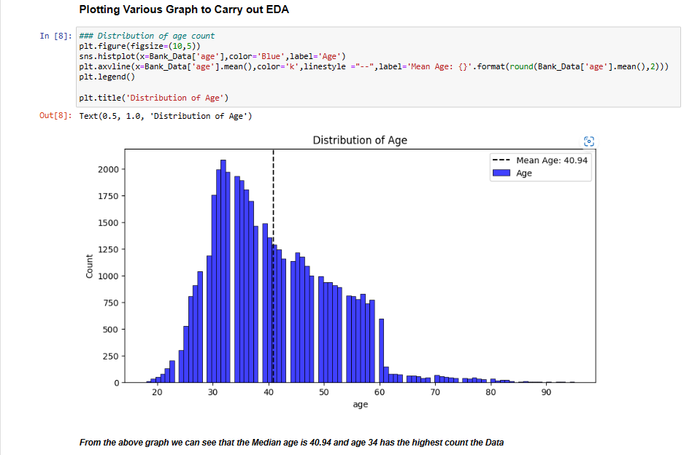

3.5 **Feature Engineering**

In Feature Engineering, Missing Value is Observed and replaced with other value, Categorical values are handled using pandas library and redundant values are dropped.

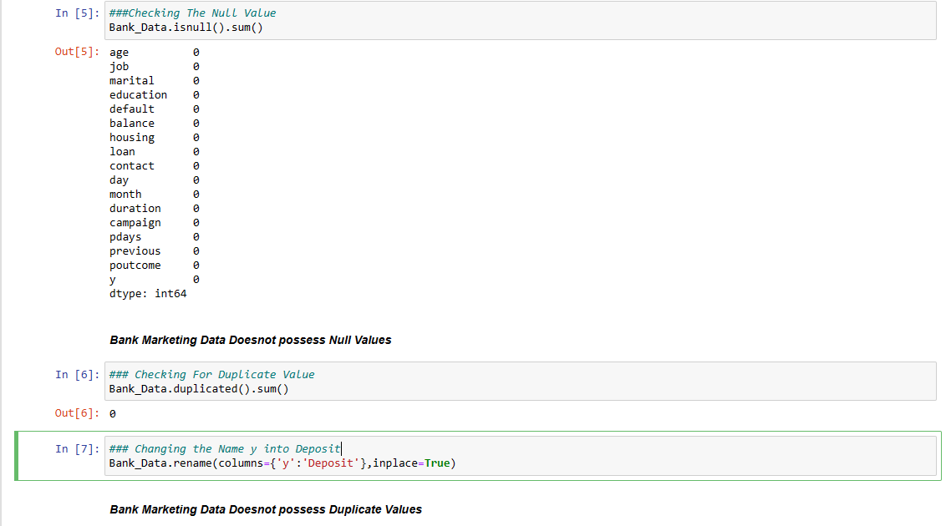

3.6 **Split into Train and Test Data**

Now, the clean dataset is split into train and test dataset by using the Sklearn library, which is a required process during the model training part.



3.7 **Label Encoder and Get Dummies**

Now the dataset is encoded using the Sklearn library, which helps to encode the data if the data is not encoded, which is a required process during the model training part.

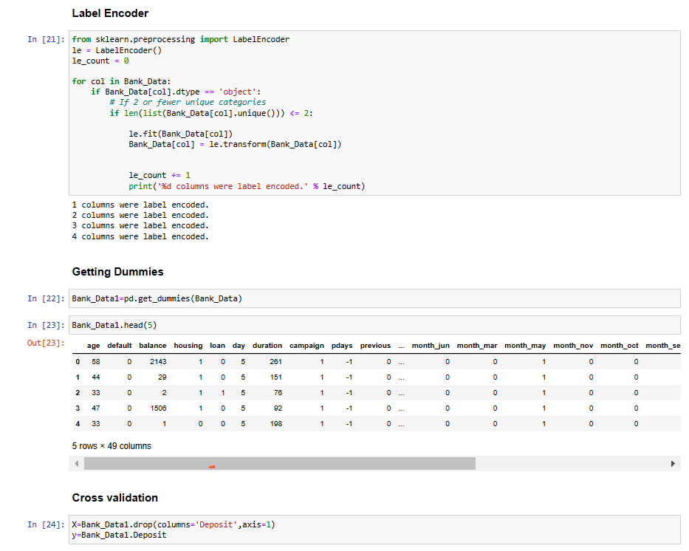

3.8 **Hyper parameter Tuning**

For the efficient and more precise training of the model, Hyper parameter tuning is a vital part before train a model, which helps to attains desired level of accuracy during the training of the model, which elevates the accuracy of the model.

3.9 **Model Training and Model Prediction**

The dataset is trained using two different model one is Random forest Classifier and other one is XG Boost Classifier which trained the dataset into desires level of accuracy and helps to attain precise level of prediction.

**Random Forest Classifier**

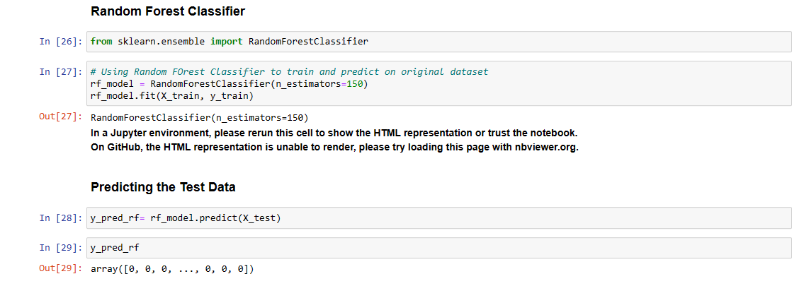

**XG Boost Classifier**

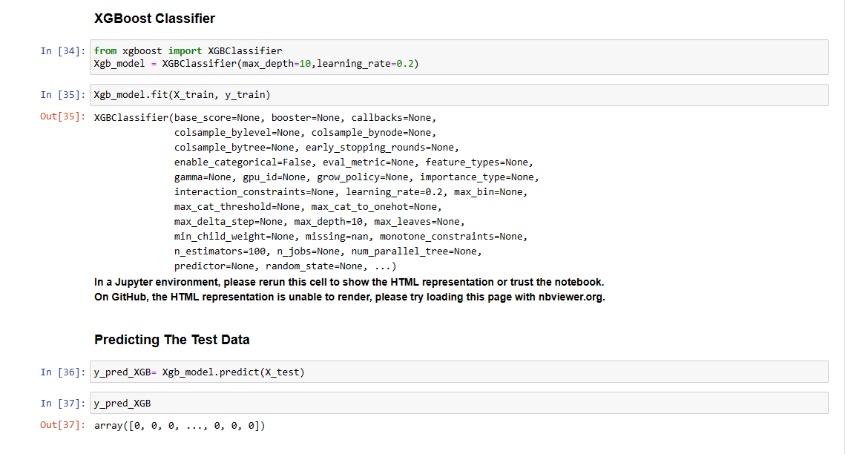

3.10 **Confusion Matrix and Mean Squared Error**

Now the Trained model is use to find the predicted values of the model and the model is evaluated using the two estimates one is Confusion Matrix and other one is Mean Squared Error, which gives an idea at what level of precision the model is trained.

**Random Forest Classifier**

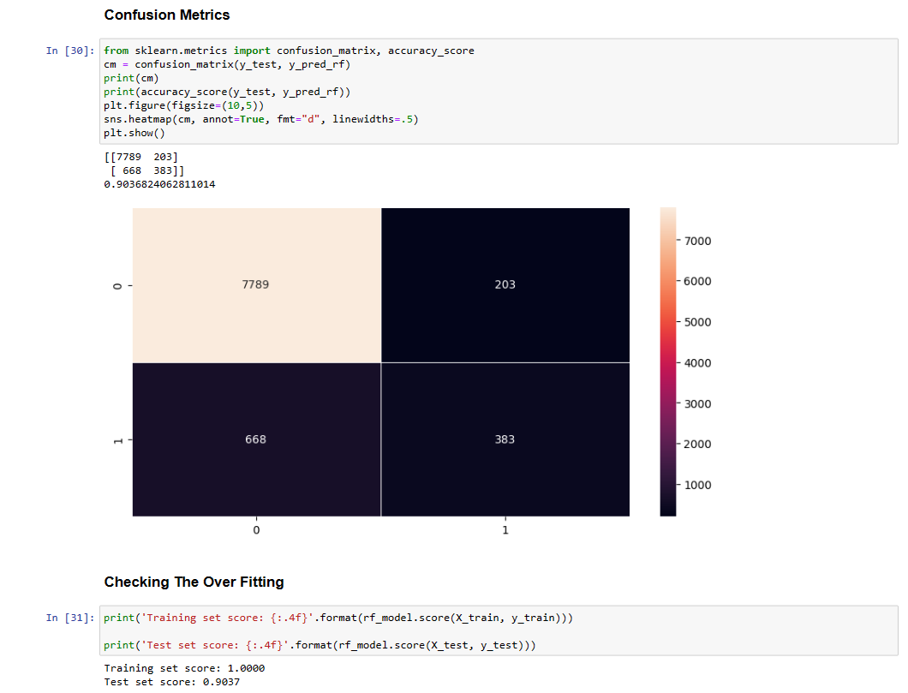

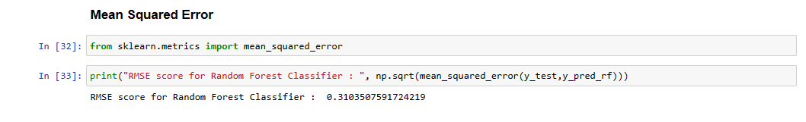

**XG Boost Classifier**

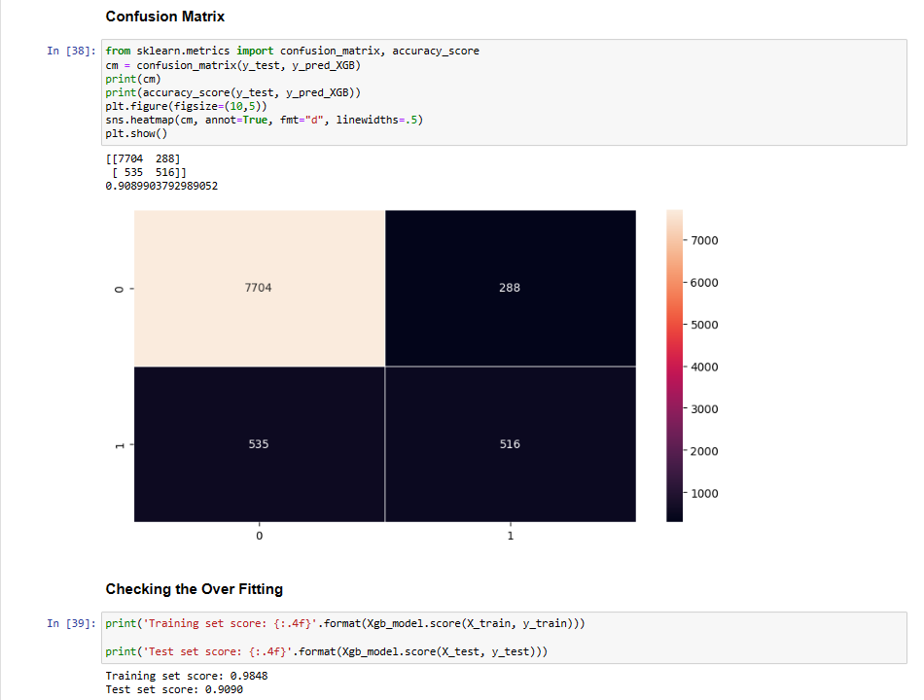

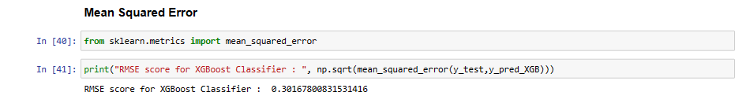

3.11 **Submission of the Predicted Values**

The final step is to submit the predicted values in the CSV form, so that it can be reuse for many other purposes.

**Random Forest Classifier and XGBoost Classifier**

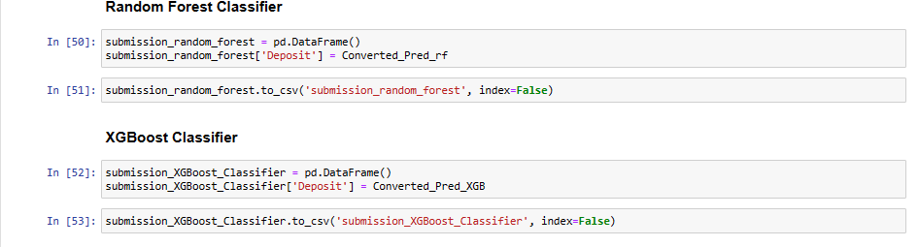

4. **Deployment**

4.1 **Load the Dataset in Power BI**

Now, Load the Dataset into Power Bi for creating the dashboard.

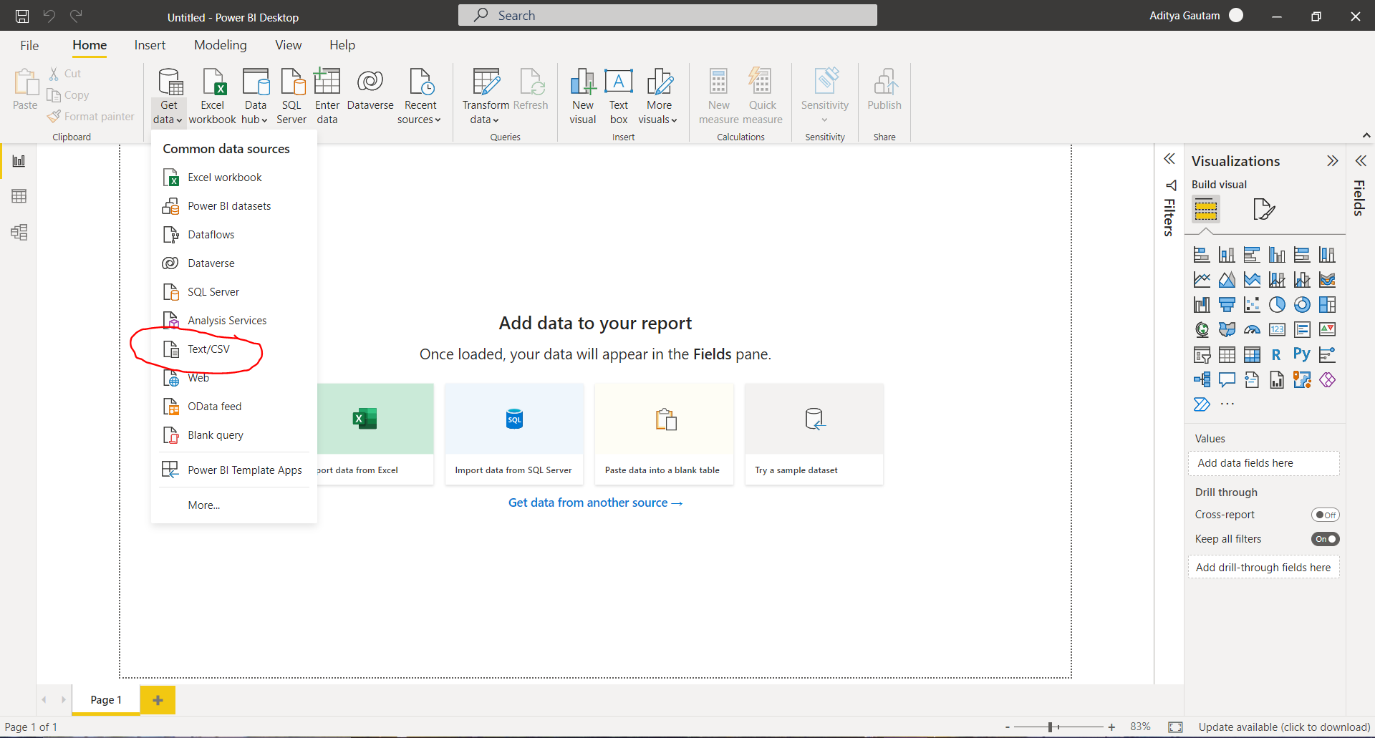

4.2 **Create the interactive dashboard**

**Random Forest Classifier**

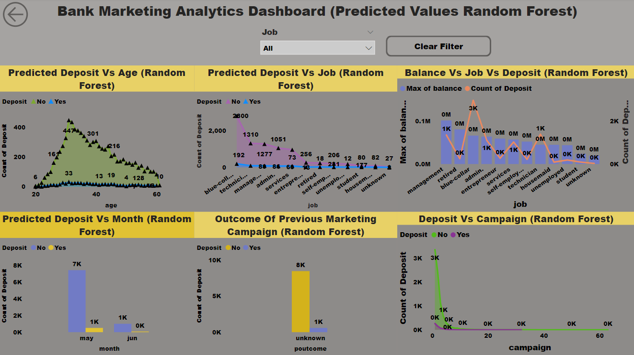

**XGBoost Classifier**

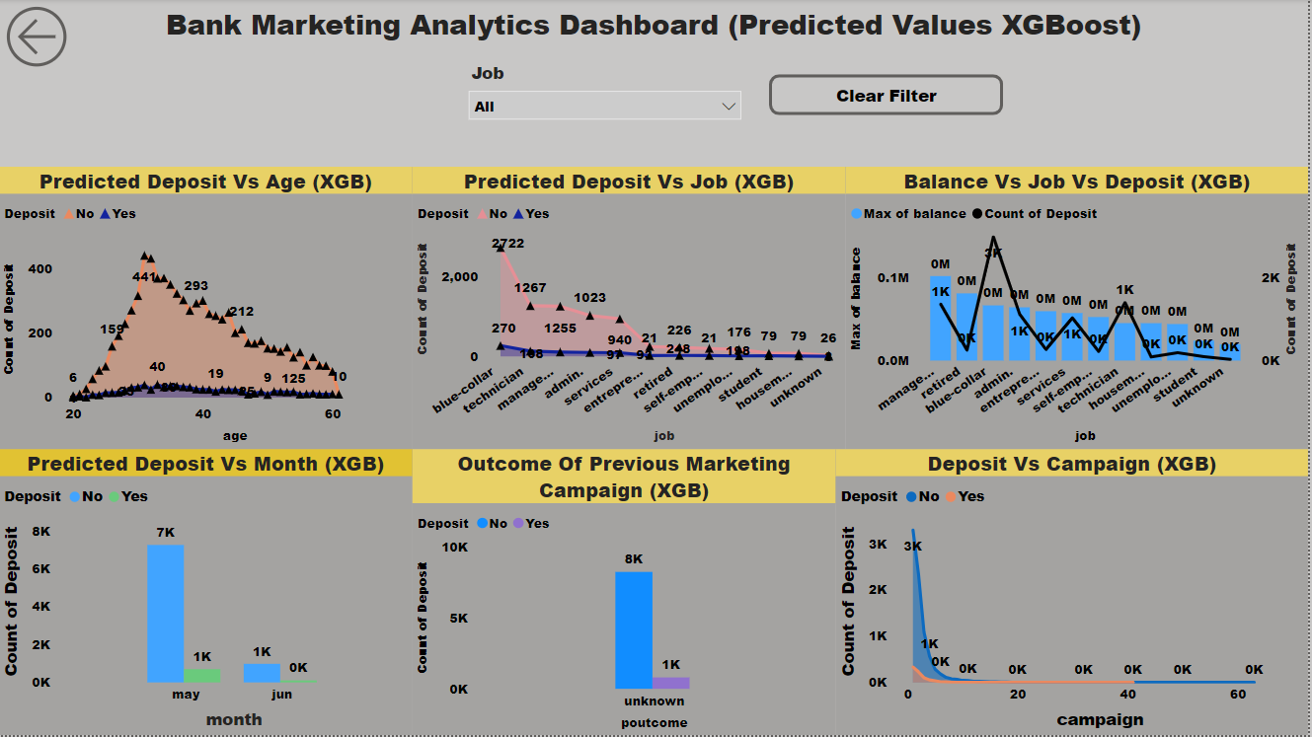

4.3 **Publish to Power Bi account**

(1)

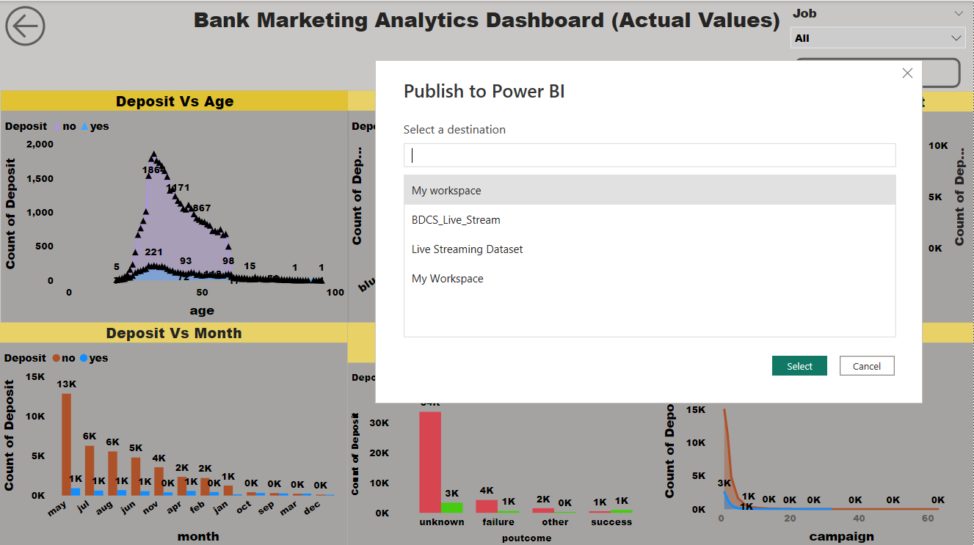

(2)

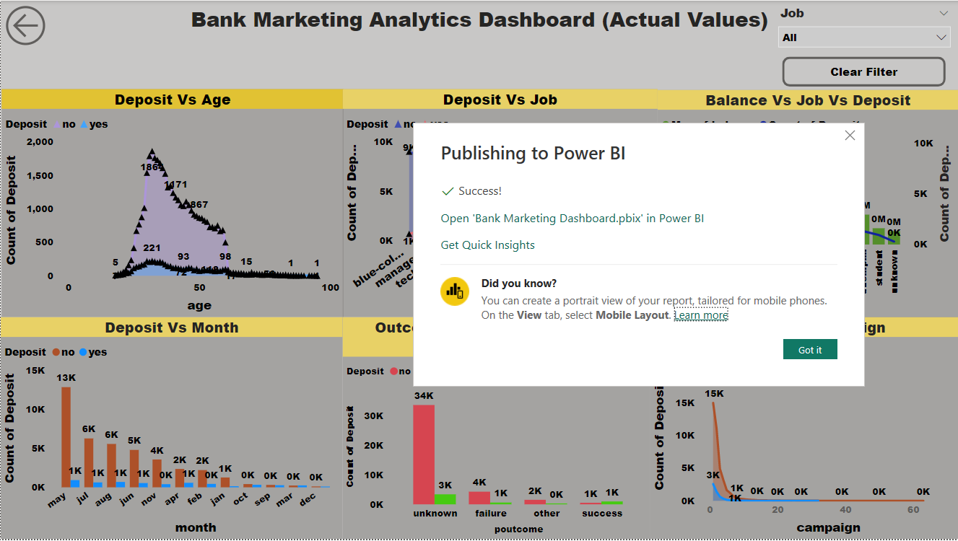

4.4 **Publish to Web**

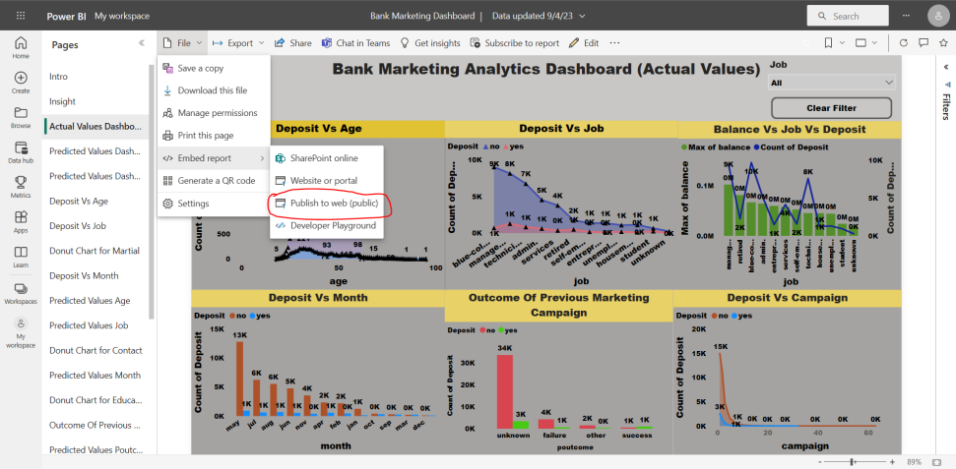

4.5 **Share the Public Link to Client**

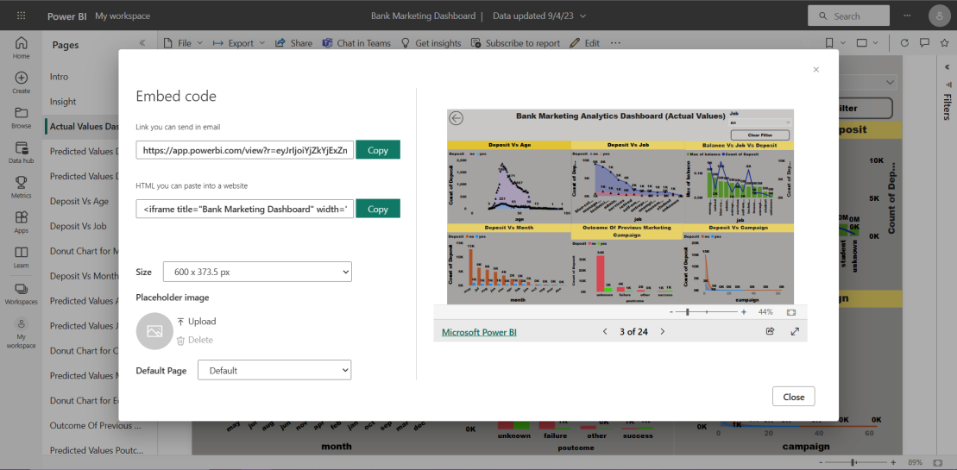

**5. Conclusion**

**5.1 Insight of Bank Marketing Analytics**

(1) In Deposit Vs Age Plot, Age 32 is the Highest Depositor with 221 deposit, where Random Forest Model predicted as Age 31 is the Highest Depositor with 33 deposit and XG Boost Model predicted as Age 31 is the Highest Depositor with 39 deposit.

(2) In Deposit Vs Job Plot, Blue Collar job is the Highest Depositor with 708 deposit, where Random Forest Model predicted as Blue Collar job is the Highest Depositor with 192 deposit and XG Boost Model predicted as Blue Collar job is the Highest Depositor with 270 deposit.

(3) In Balance Vs Job Vs Deposit Plot, Management job has the Maximum Balance with 102127 Balance and Highest Depositor with 9458 deposit, where Random Forest Model predicted as Management job has the Maximum Balance with 102127 Balance and Highest Depositor with 1363 deposit and XG Boost Model predicted as Management job has the Maximum Balance with 102127 Balance and Highest Depositor with 1363 deposit.

(4) In Deposit Vs Month Plot, May Month has the Highest Depositor with 925 deposit, where Random Forest Model predicted as May Month has the Highest Depositor with 508 deposit and May Month has the Highest Depositor with 699 deposit.

(5) In Previous Marketing Campaign Plot, Unknown Category is the Highest Depositor with 3386 deposit, where Random Forest Model predicted as Unknown Category is the Highest Depositor with 586 deposit and Unknown Category is the Highest Depositor with 804 deposit.

(6) In Deposit Vs Campaign Plot, Day 1 has the Highest Depositor with 2561 deposit, where Random Forest Model predicted as Day 1 has the Highest Depositor with 263 deposit and XG Boost Model predicted as Day 1 has the Highest Depositor with 332 deposit.

(7) After Analyzing the Whole Dataset, It is Predicted that Bank will lose 70%-80% of depositor in the future. So if the bank takes appropriate measures, it can save up to 70%-80% depositor in the future.